1) How-to-count-distance-to-the-previous-zeroFor each value, count the difference of the distance from the previous zero (or the startof the Series, whichever is closer) and if there are no previous zeros,print the positionConsider a DataFrame df where there is an integer column {'X':[7, 2, 0, 3, 4, 2, 5, 0, 3, 4]}The values should therefore be [1, 2, 0, 1, 2, 3, 4, 0, 1, 2]. Make this a new column 'Y'.

**Solution:**

Code:

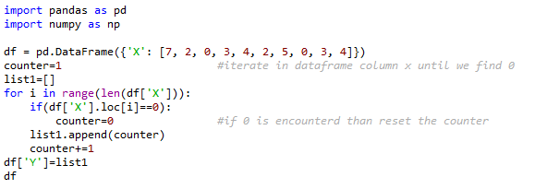

Input & Result

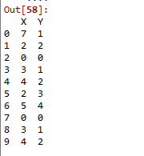

2) Create a DatetimeIndex that contains each business day of 2015 and use it to index a Series of random numbers.

**Solution:**

Code:

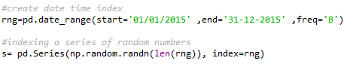

Input & Result

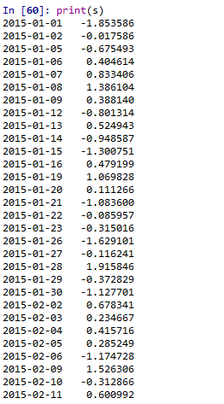

…………………

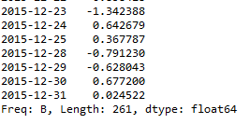

3) Find the sum of the values in s for every Wednesday

**Solution:**

Code:



Input & Result



4) Average For each calendar month

**Solution:**

Code:



Input & Result

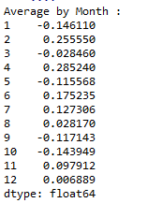

5) For each group of four consecutive calendar months in s, find the date on which the

highest value occurred.

**Solution:**

Code:



Input & Result

